Notes le titre
Table des matières
Section 2 : UML Unified Modelling Language 2
4. What is UML Unified Modelling Language 2
5. Different Types of UML Diagrams 2
6. Tools for Designing and Drawing UML Diagrams 5
Section 3 UML Class Diagram 7
7. Class Diagram 7
8. Class Diagram Examples 19
9. Common Mistakes in UML Class Diagrams 22
Section 4 : UML Object Diagram 26
11. Object Diagram 26
12. Object Diagram Examples 26

Section 2 : UML Unified Modelling Language

4. What is UML Unified Modelling Language



Vous pouvez donc dire que le modèle est une version finale d'un produit qui est réalisée avant le début du travail proprement dit.

Des modèles sont souvent construits afin de mieux comprendre les systèmes existants ou futurs.

5. Different Types of UML Diagrams

The latest version of UML as of today is UML 2.5, which has a total of 14 different types of diagrams.
These diagrams are divided into two main categories structural diagram and behavioral diagram.

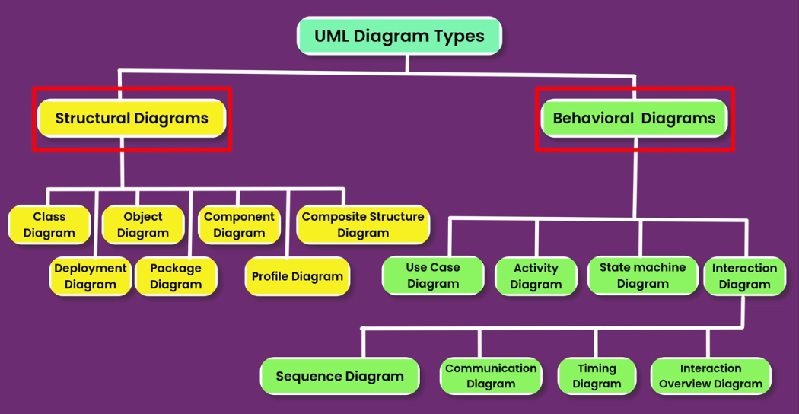

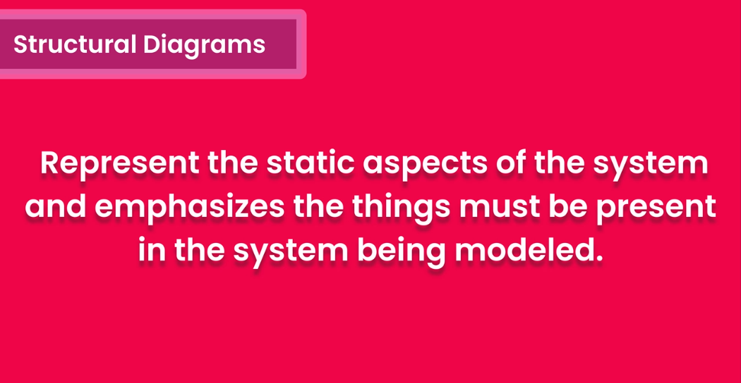

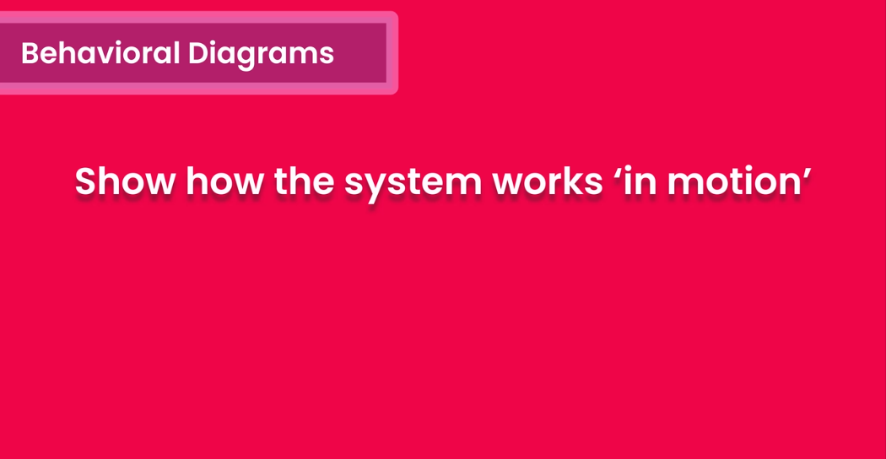

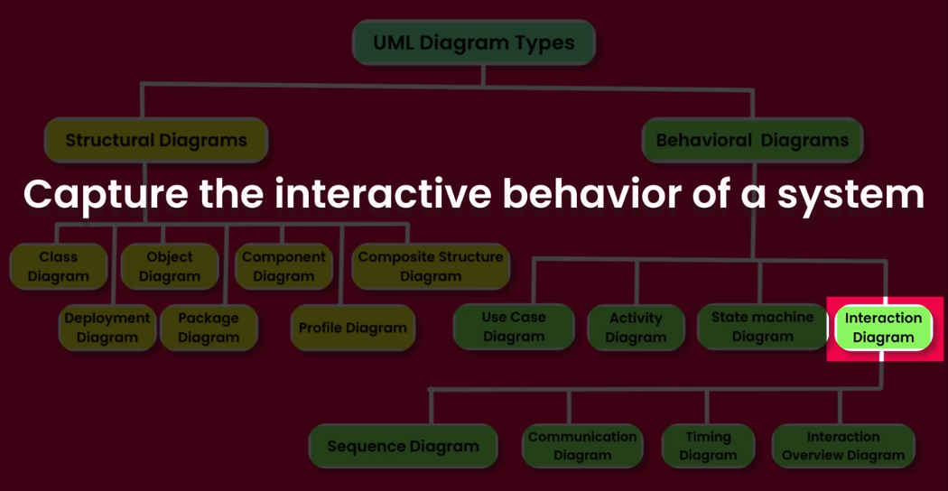

6. Tools for Designing and Drawing UML Diagrams

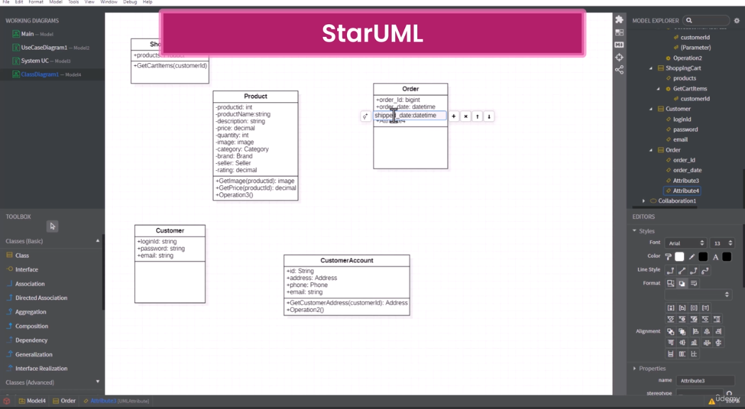
StartUML est disponible suir Windows et Ubuntu. (gratuit mais il faudra payer pour certaines fonctionnalités comme télécharger et exporter les diagrammes.
Dans la version libre, on peut télécharger et exporter mais il y aura le filigrane StartUML
⇒ dans ce cours StartUML sera utilisé.

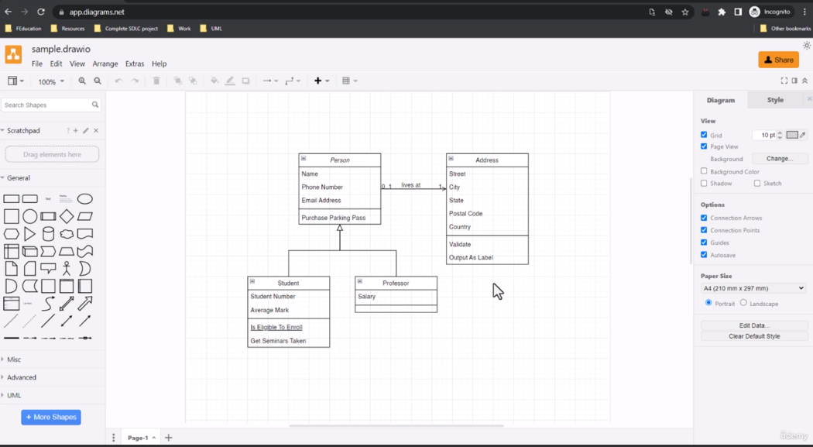
draw.io est bien mais il manque certaines fonctionnalités.

PlantUML

Les diagrammes sont créés à partir de texte.

Lucidchart

Visual Paradigm
Plateforme payante

Section 3 UML Class Diagram

7. Class Diagram

Ce diagramme offre une vue d'ensemble de la composante structurelle et statique de l'ensemble du système.

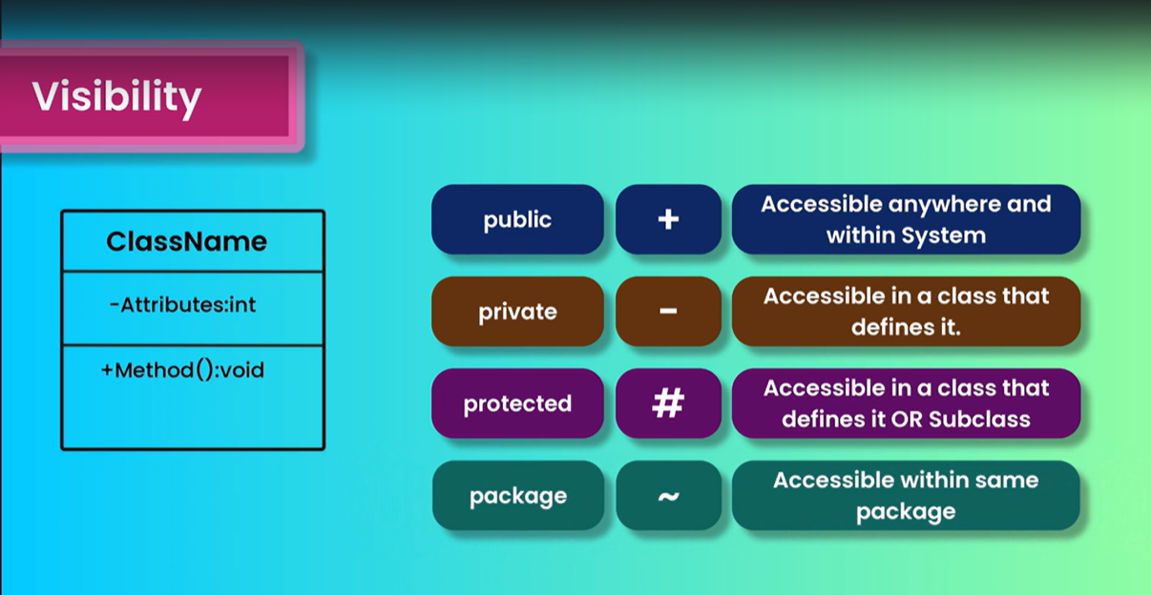



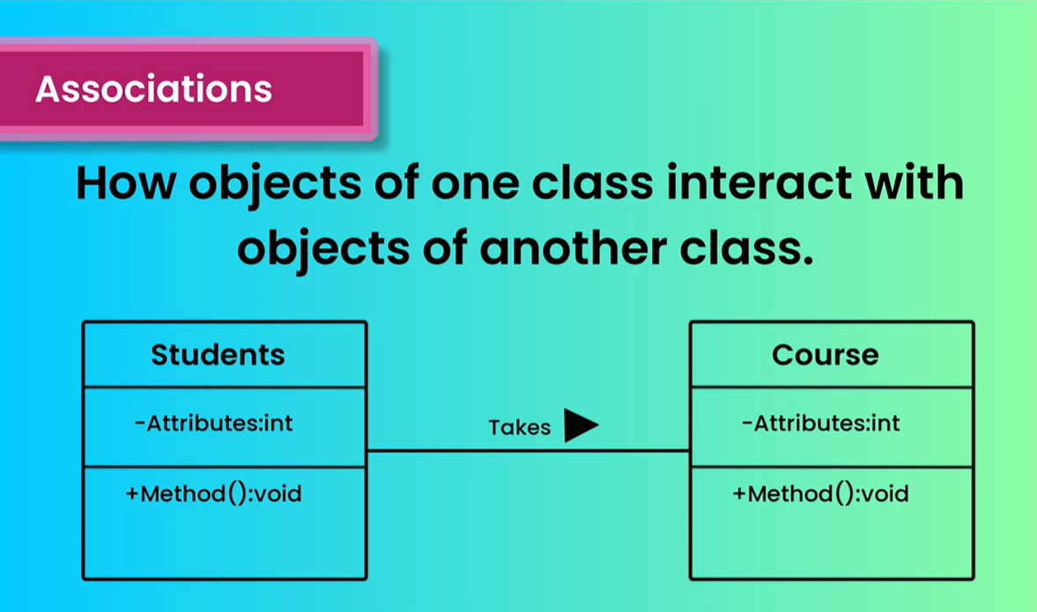

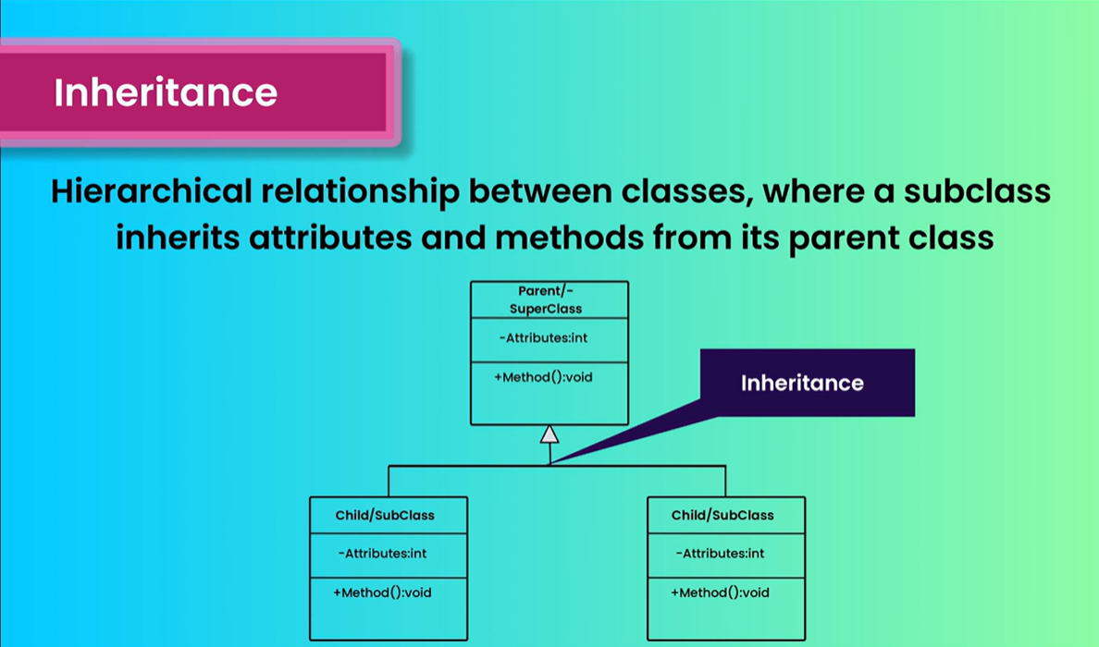

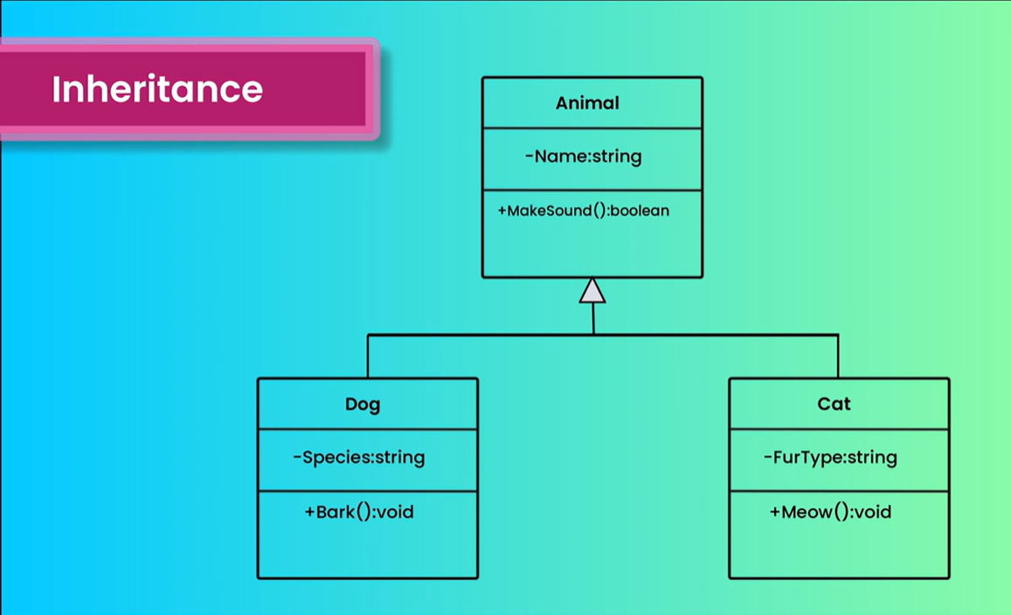

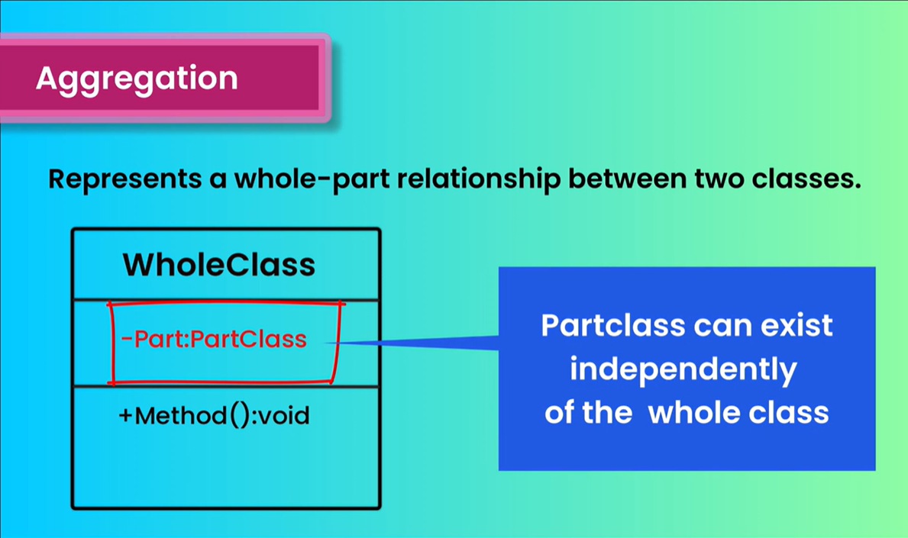



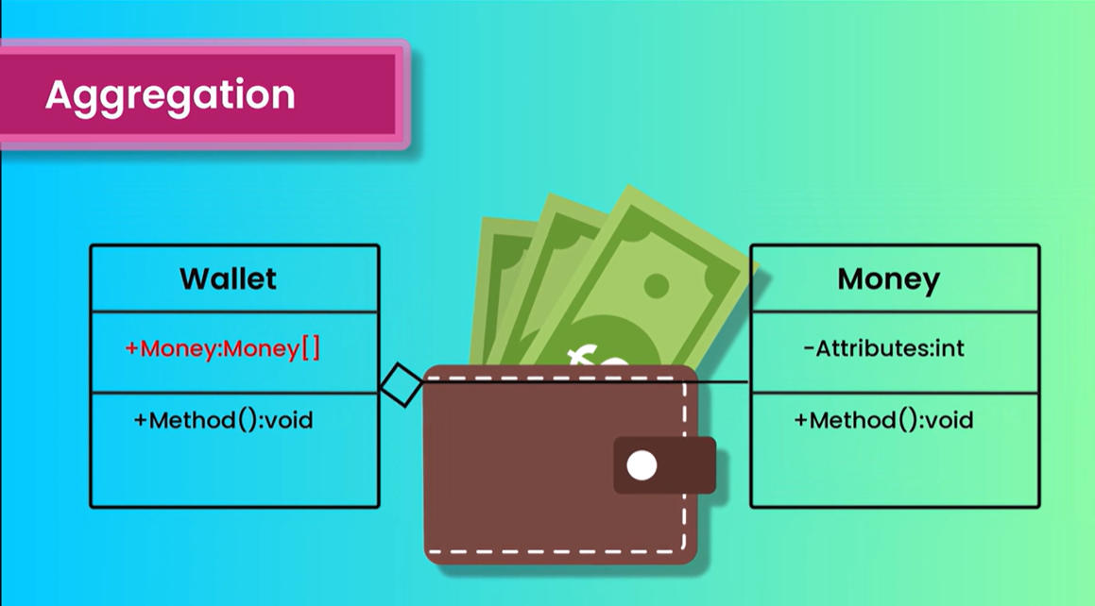

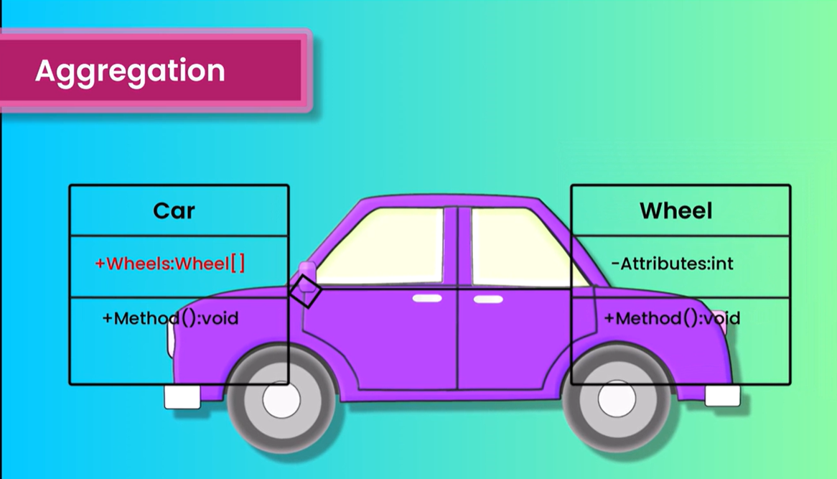

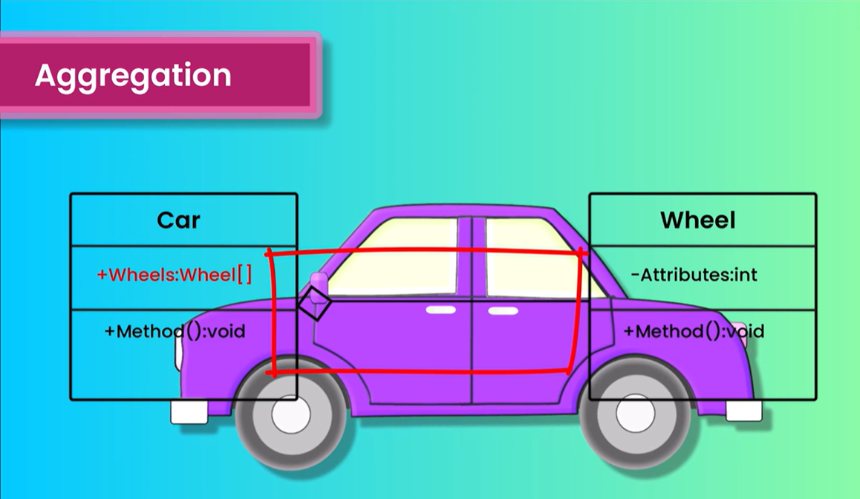



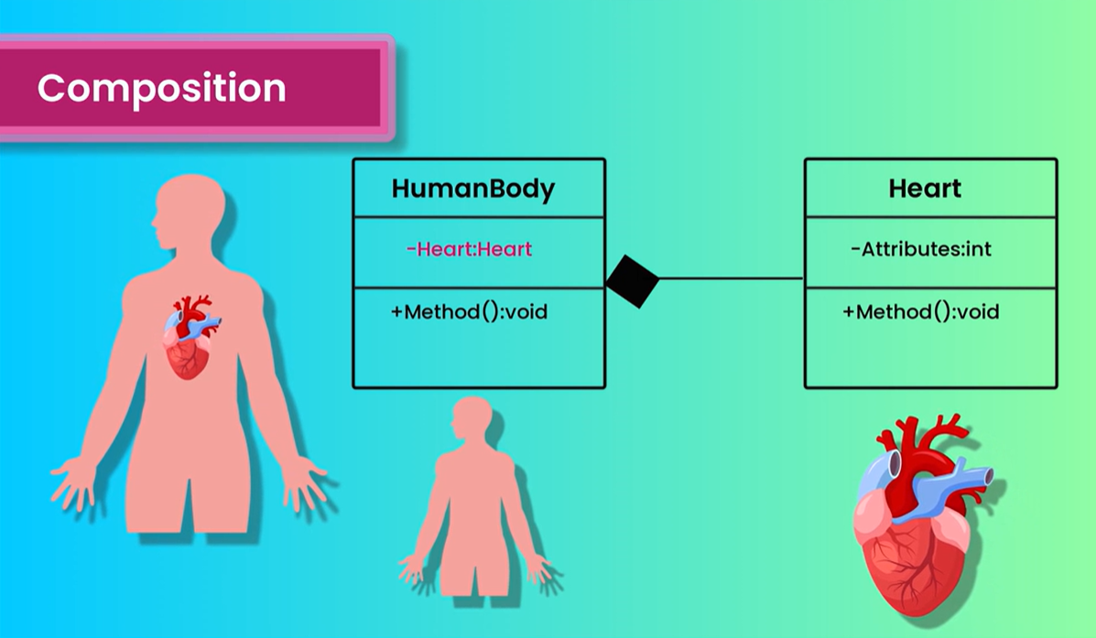

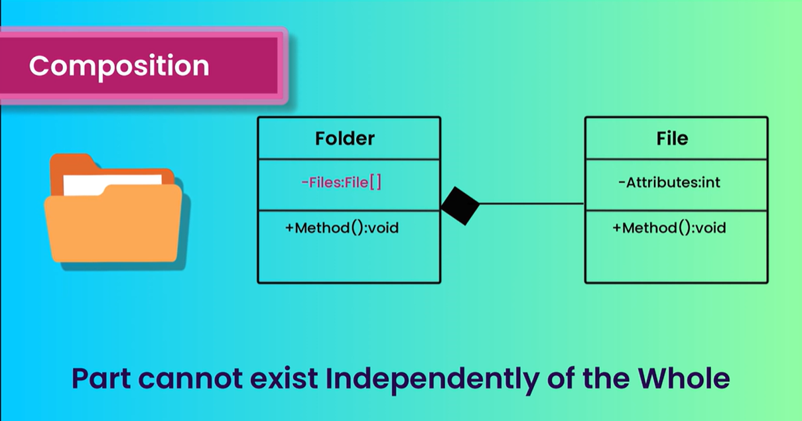

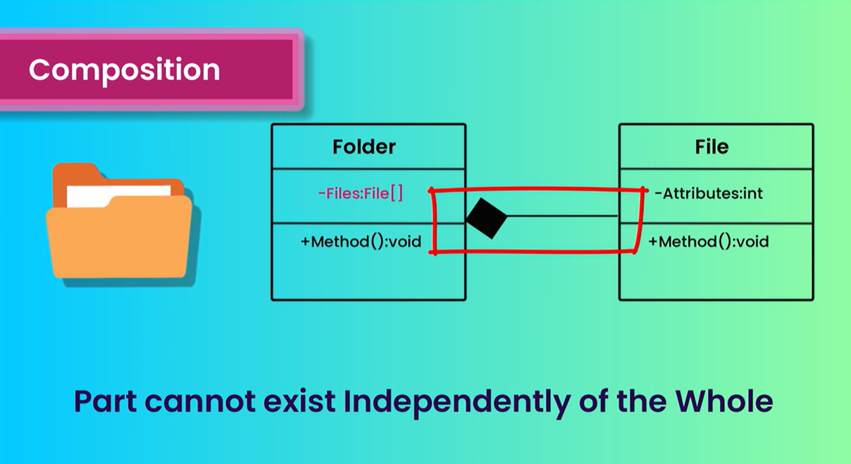

The next type of relationship is realization relationship the realization relationship in represent
how one element implements the behavior specified by another element.
It is commonly used to model the relationship between an interface or an abstract class and its implementations.

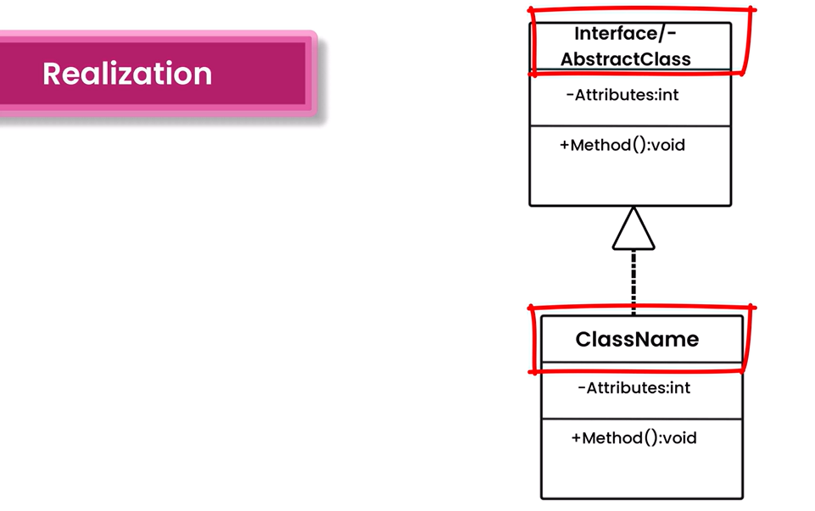

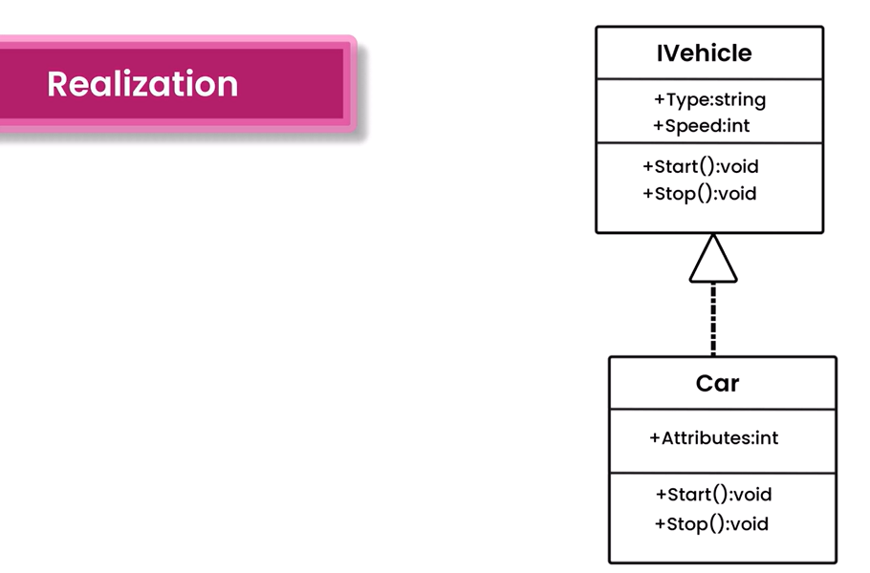

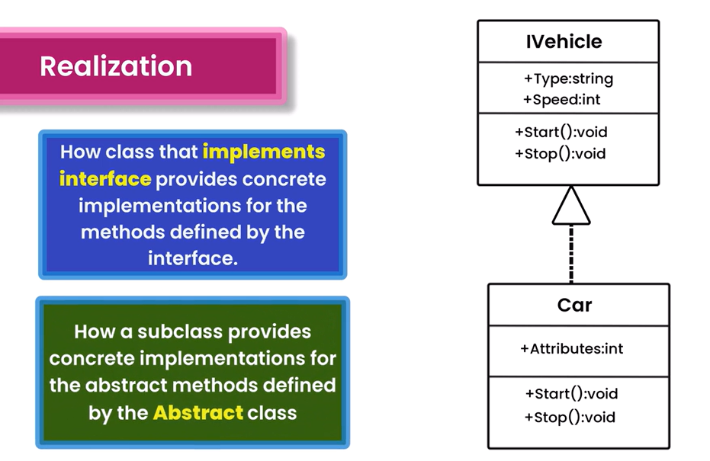

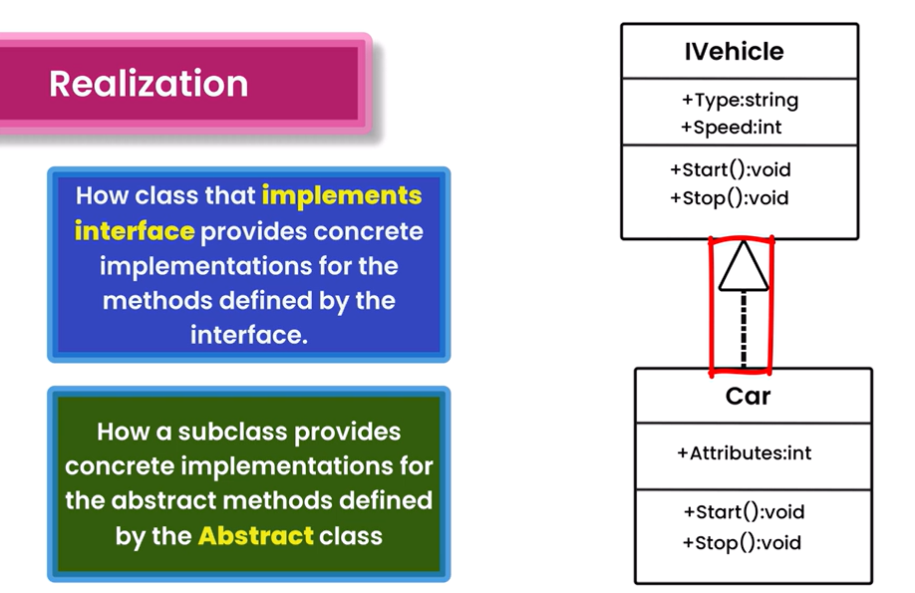

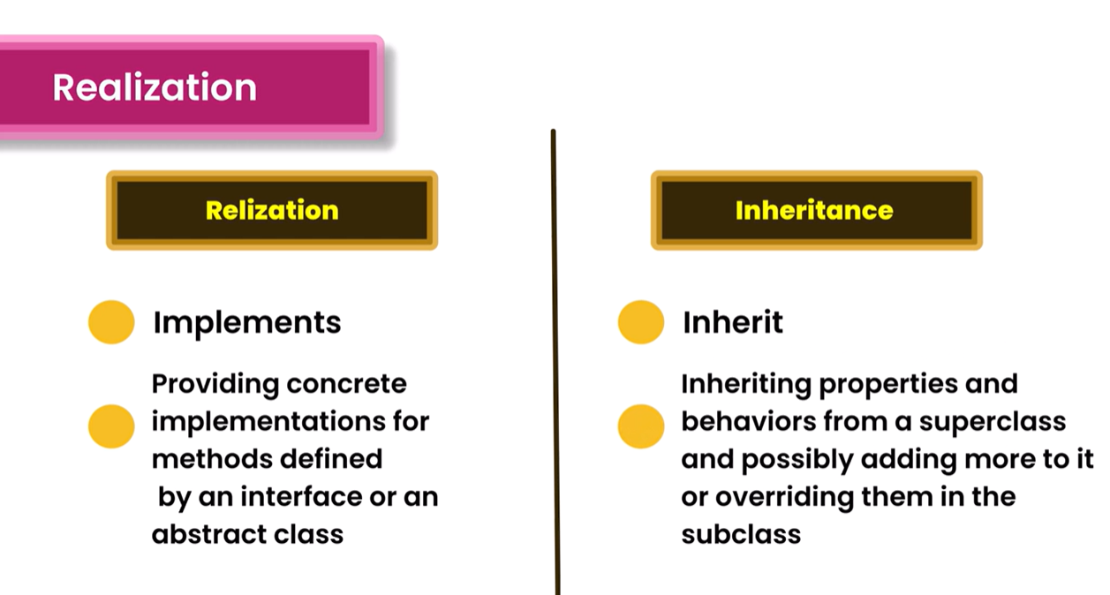

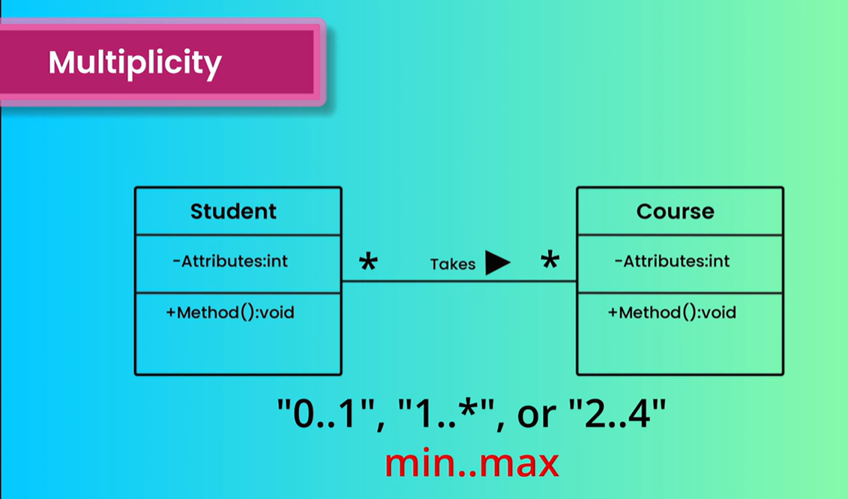

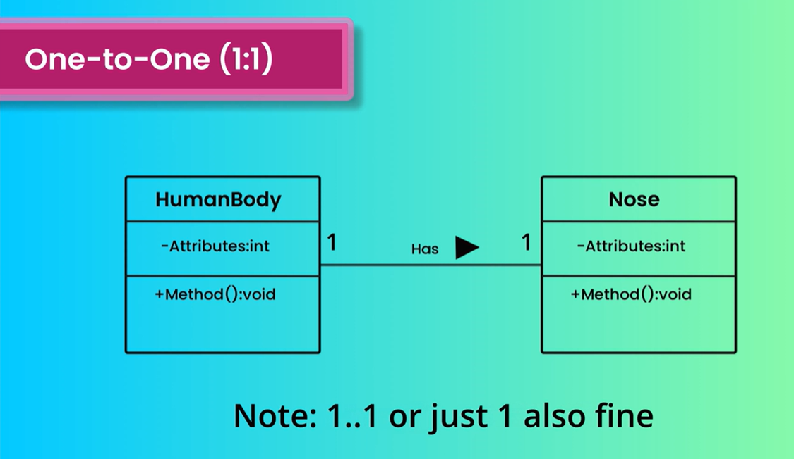

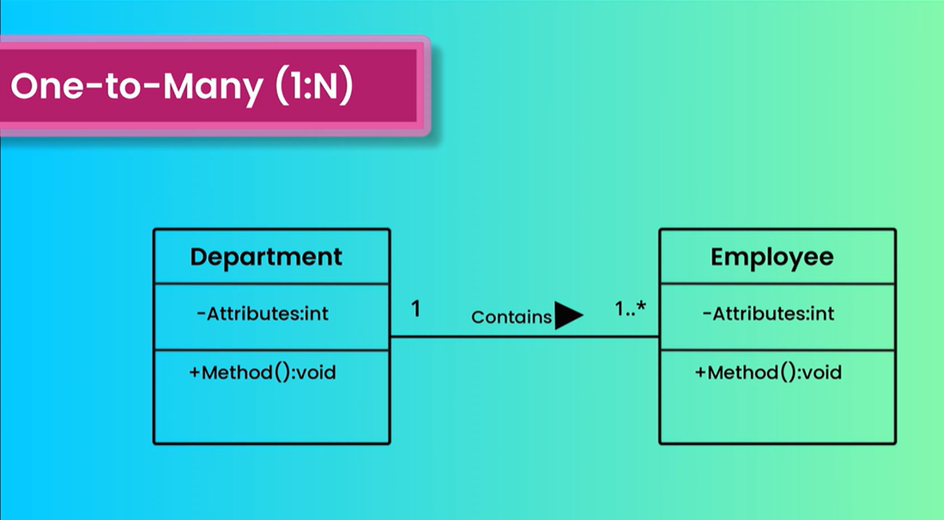

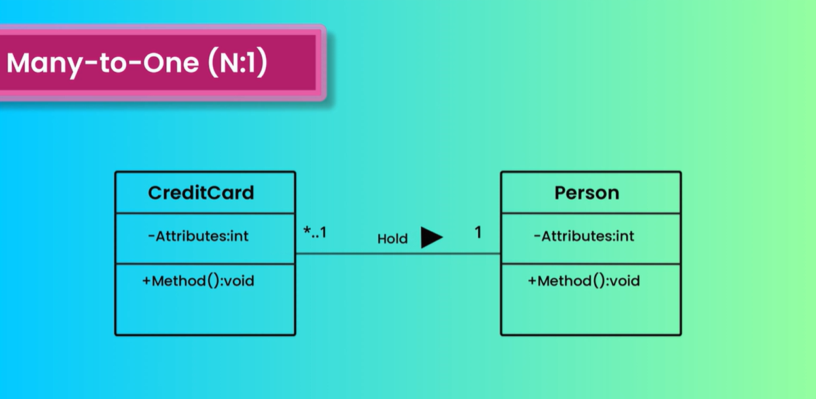

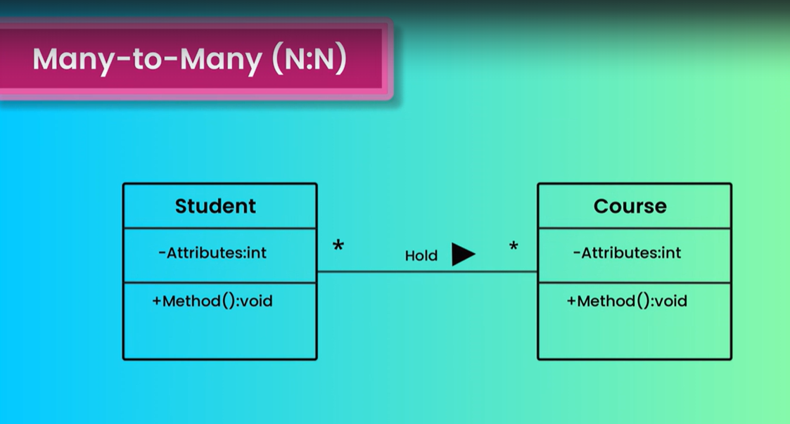

8. Class Diagram Examples
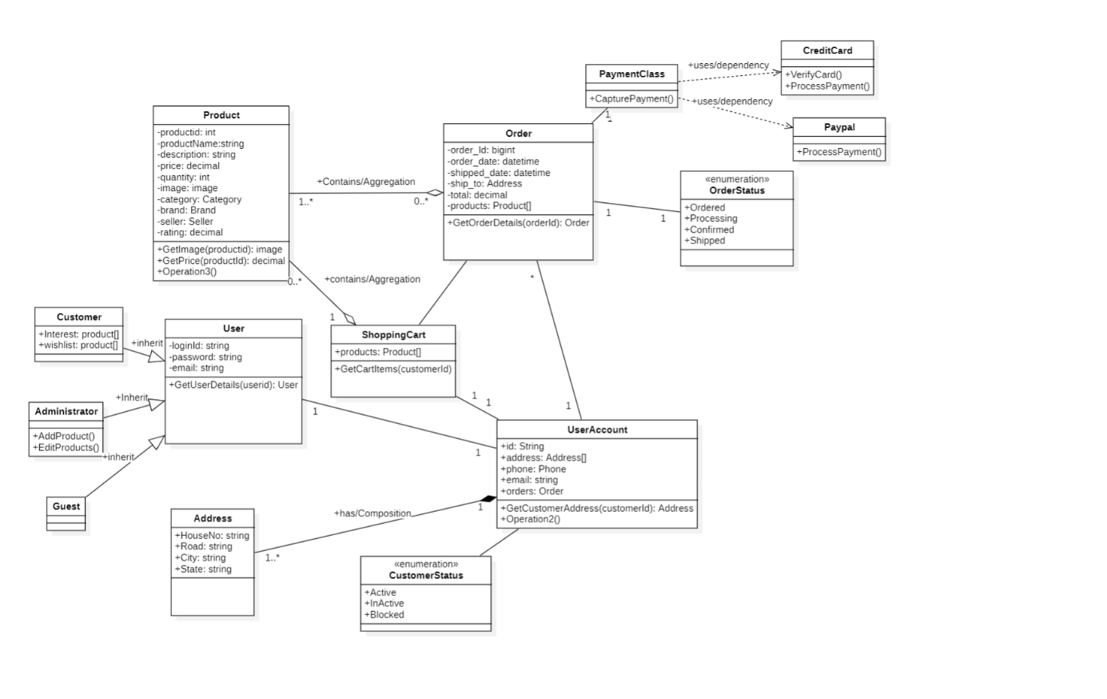

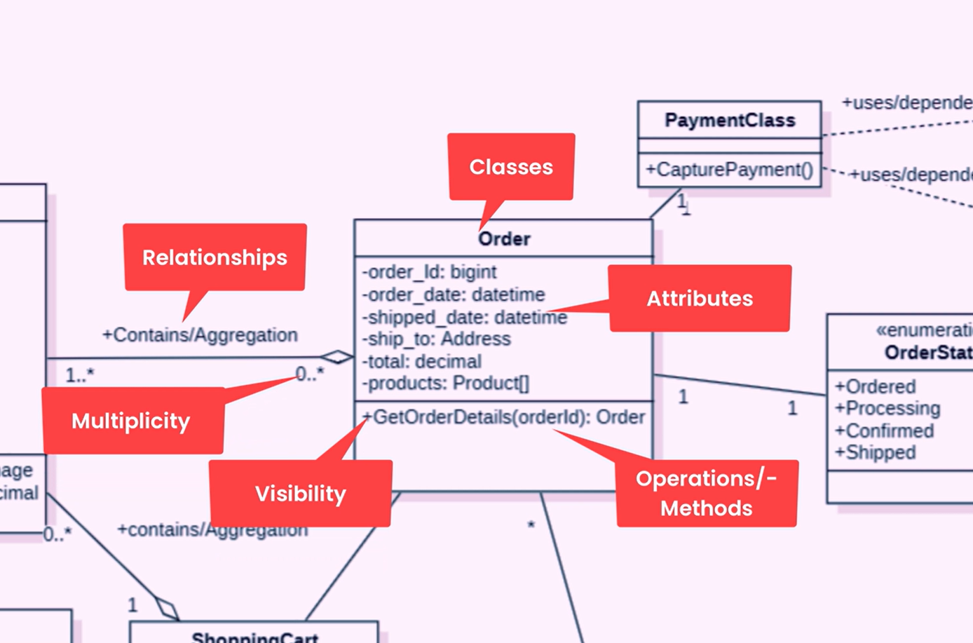

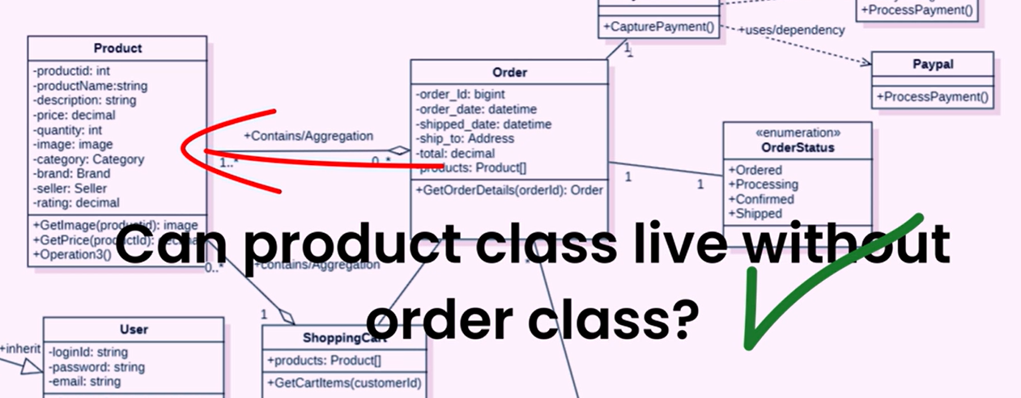

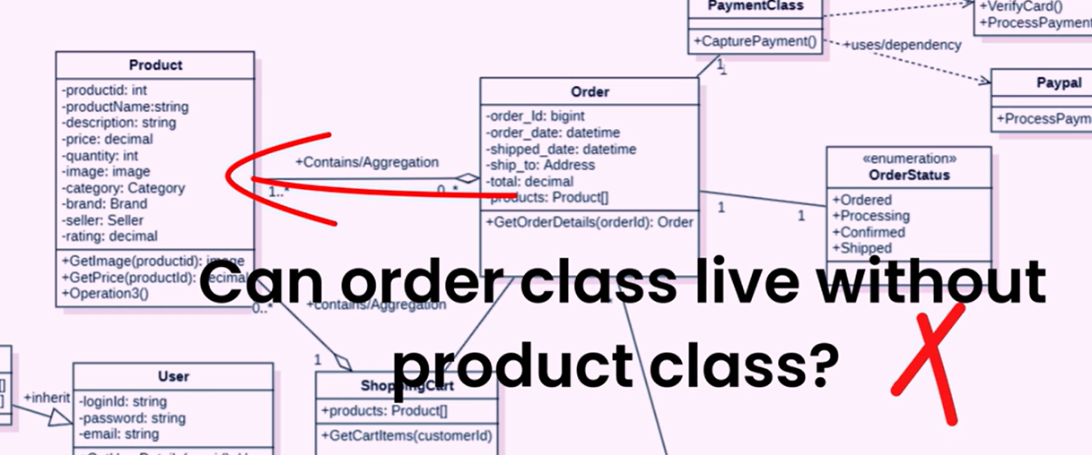

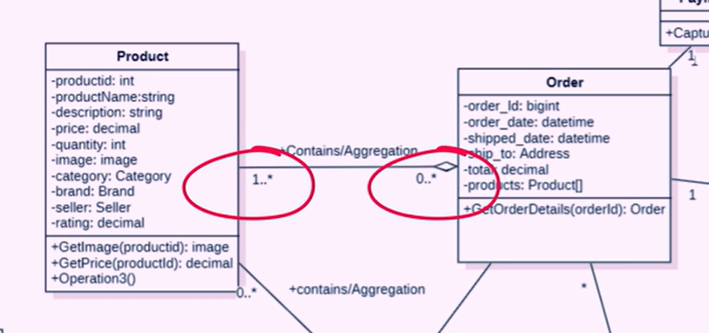

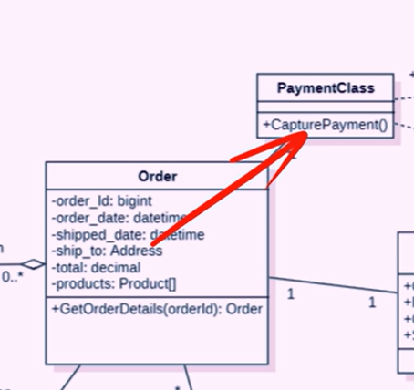

Association oneToOne
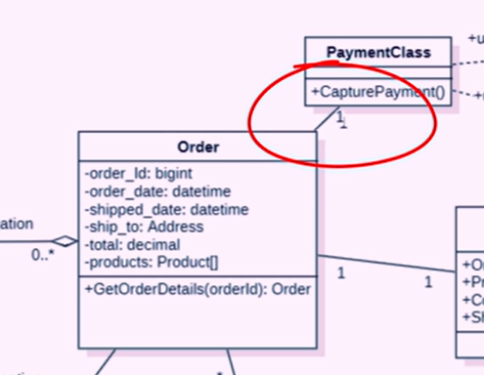

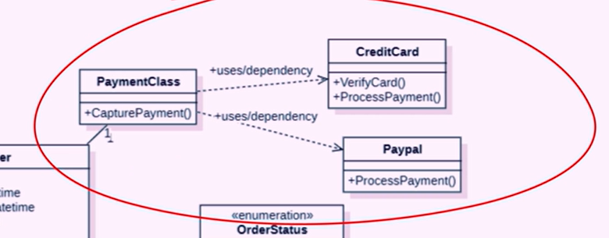

9. Common Mistakes in UML Class Diagrams

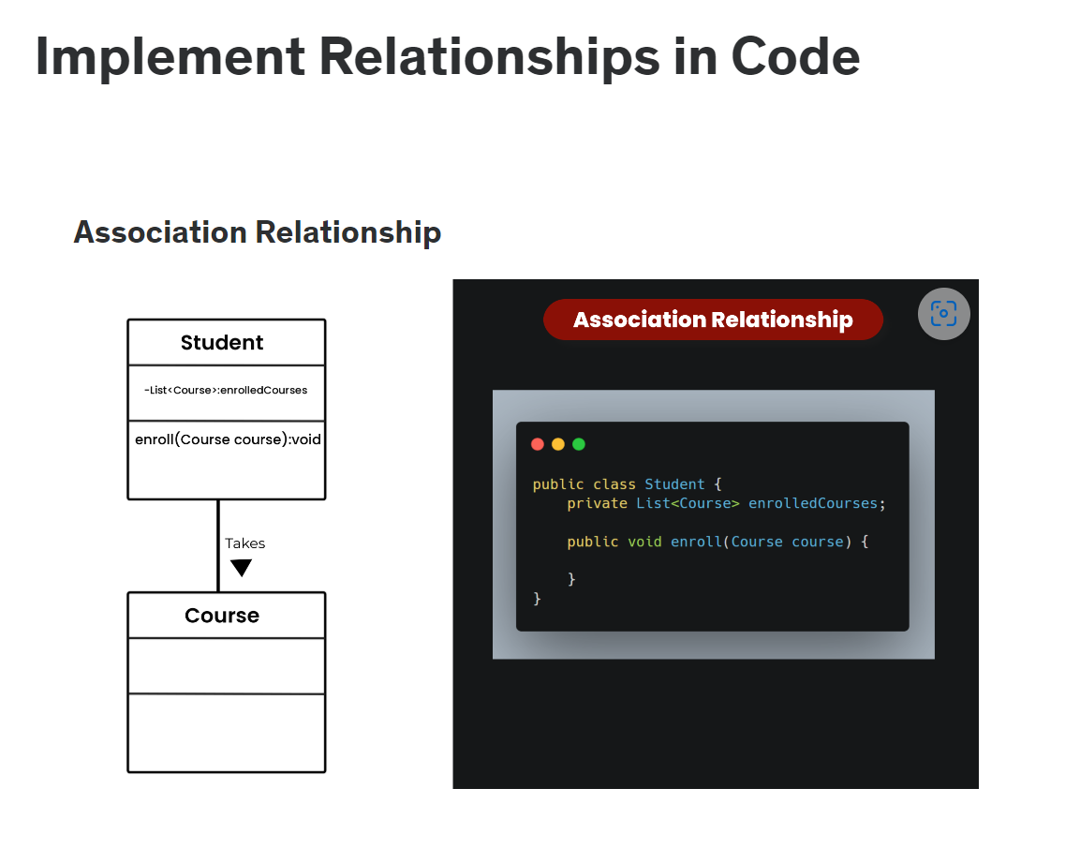

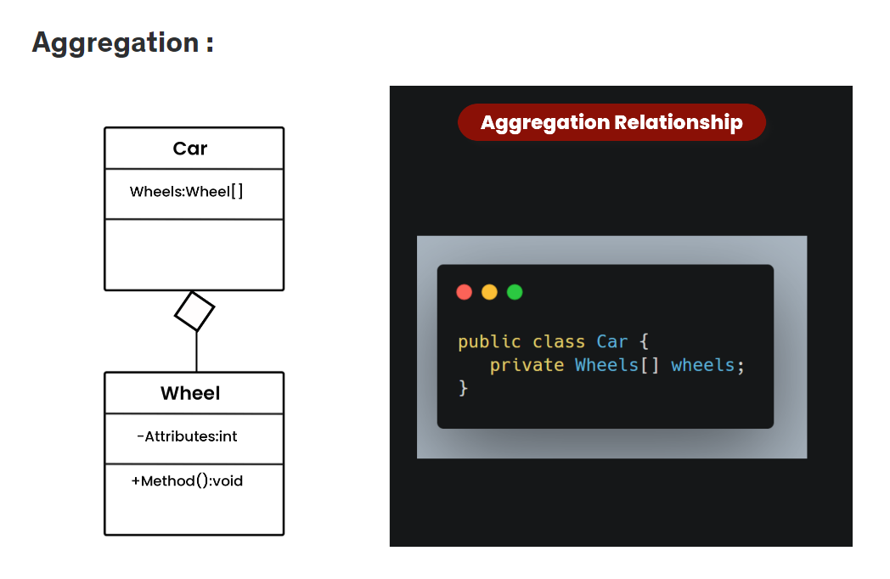

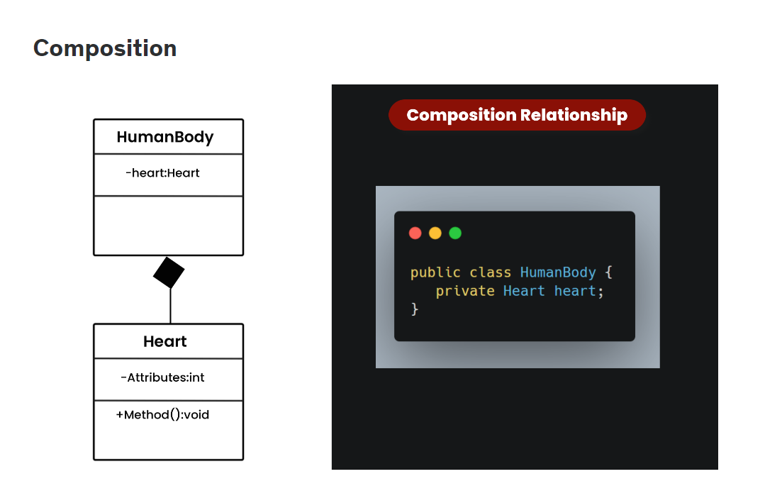

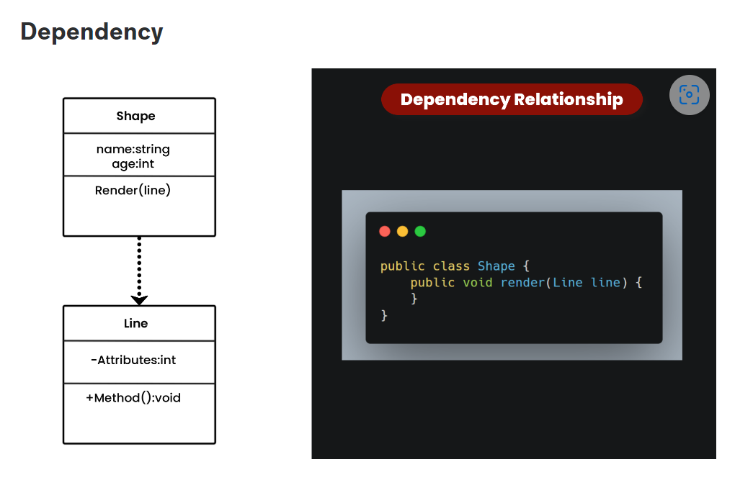

java - How to express dependency in a UML Class Diagram? - Stack Overflow

Whenever one class has a reference/uses another, it is said to have a dependency on it. In your example, class a uses class b. Therefore class a has a dependency on class b. For that, you can use the UML dashed line with open arrow as described here.
This is a very general relationship.
One class depends on another if the independent class is a parameter variable or local variable of a method of the dependent class.
If your class a had an instance variable, you would use the association link instead.

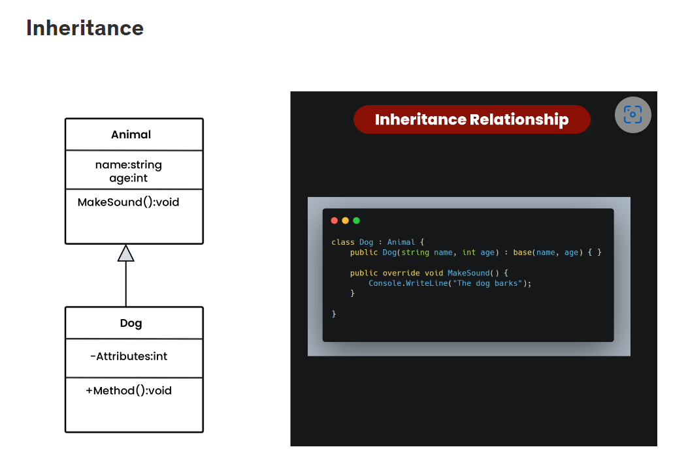

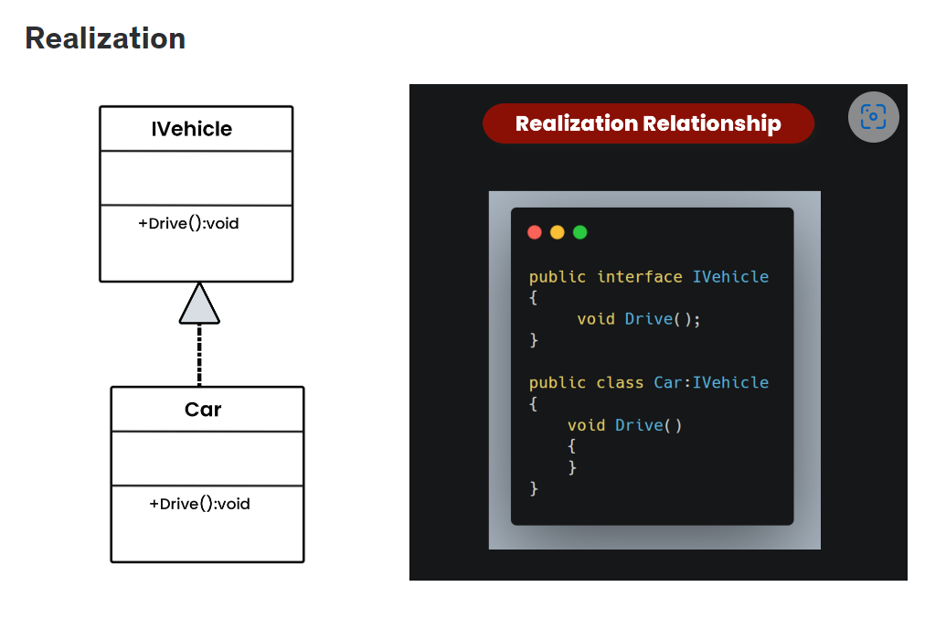

Section 4 : UML Object Diagram

11. Object Diagram
Prendre des captures d’écran sur Linux

12. Object Diagram Examples



